Azure DevOps – Theoretical Assignment
“TeamPulse” — a web-based project management dashboard
The EPIC,FEATURES,USER STORIES & TASKS

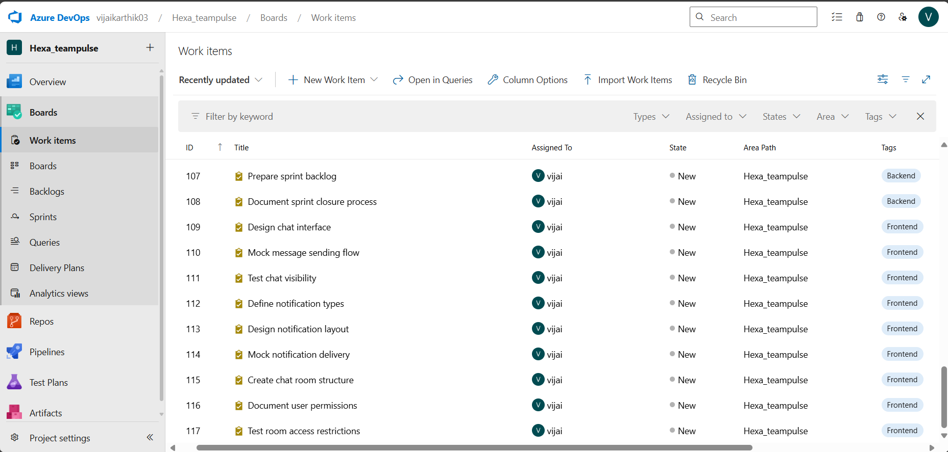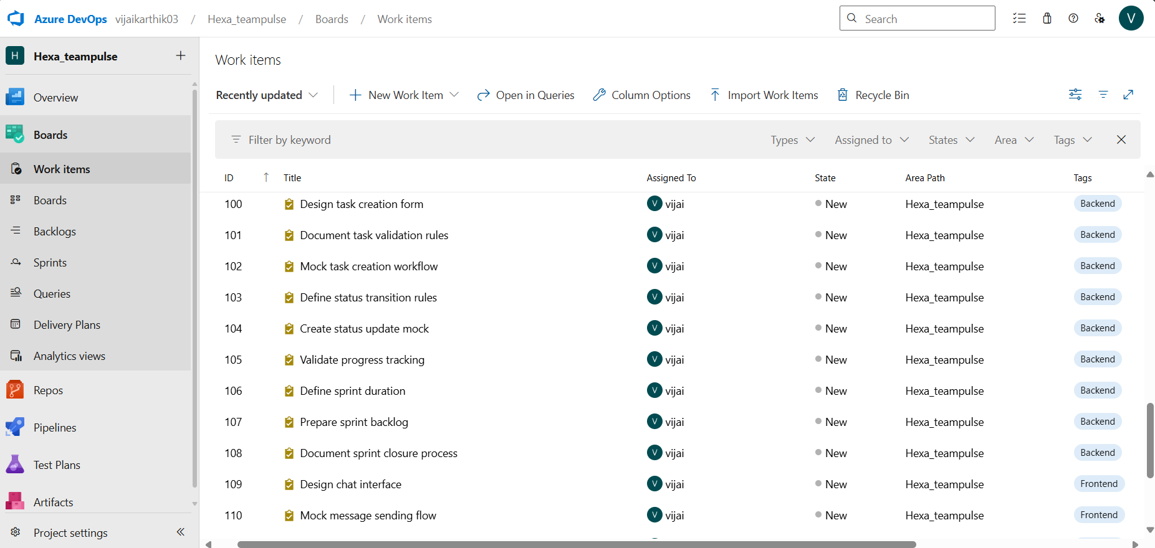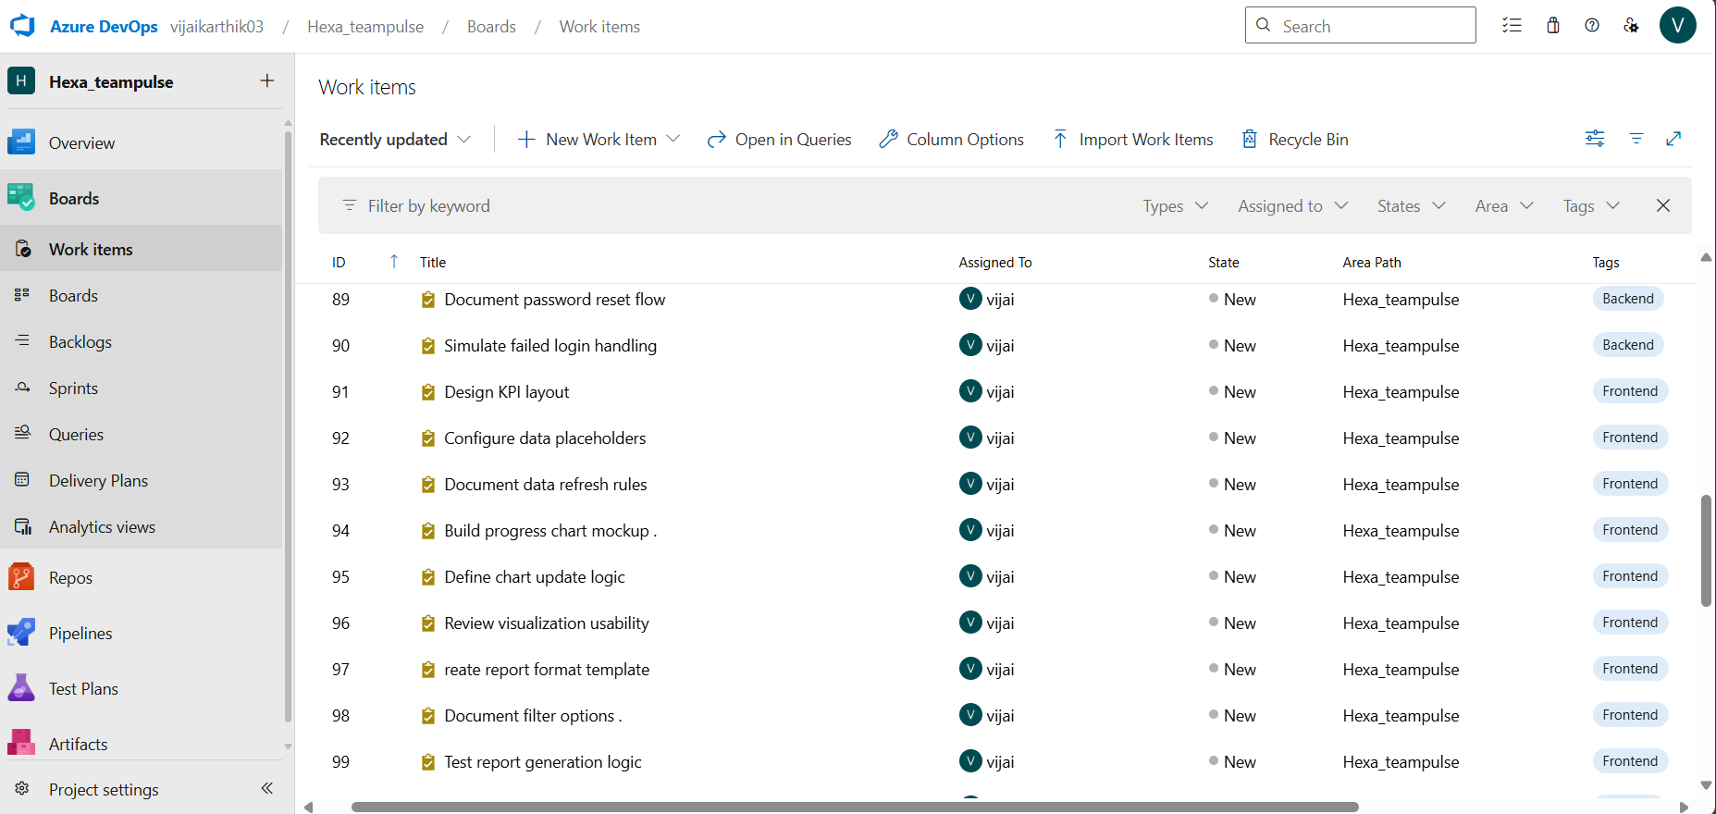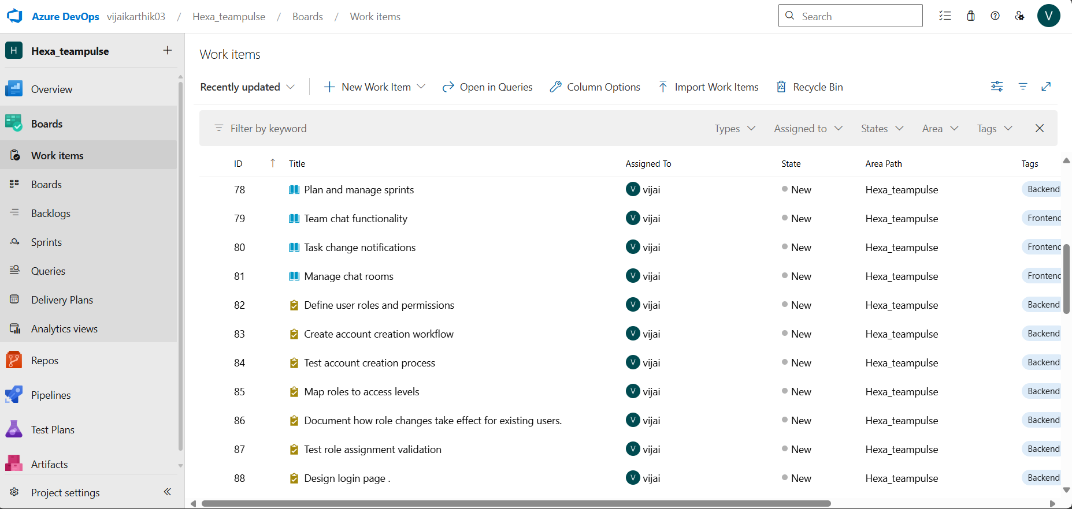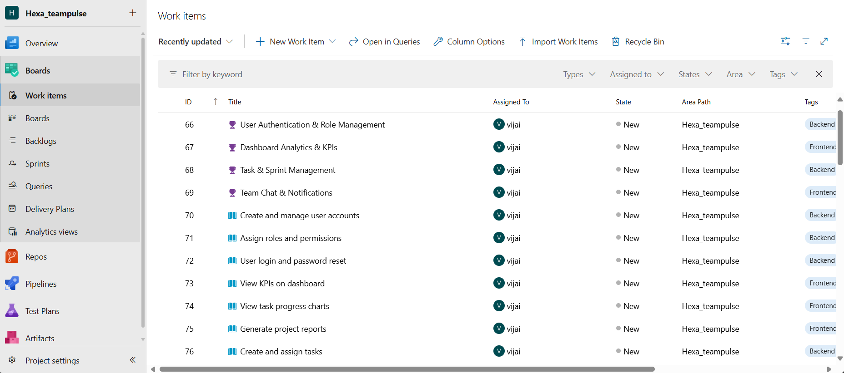
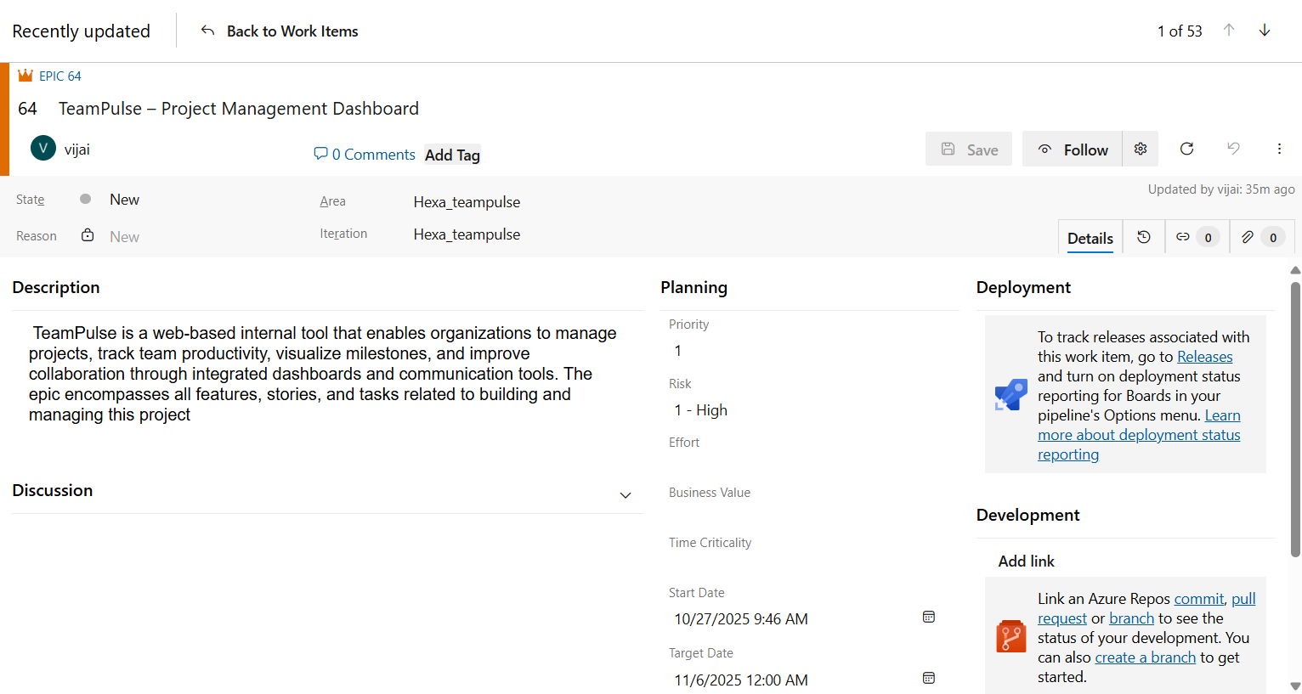

Board view

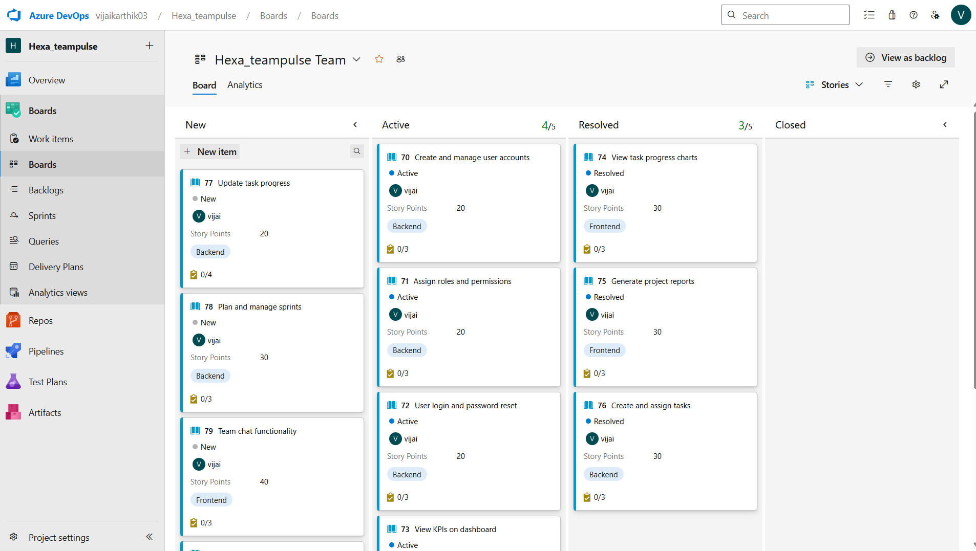

How Azure DevOps Supports Agile Methodology
Azure DevOps provides structured tools like Boards, Backlogs, and Sprints that align with Agile principles. It enables:
- Iterative development through sprint planning and tracking.
- Transparency in project progress via dashboards.
- Collaboration among team members through work items and discussions.
- Traceability from Epic → Feature → Story → Task.
- Continuous improvement by monitoring performance and burndown charts.

Benefits of Breaking Large Projects into Smaller Work Items
- Easier task tracking and responsibility distribution.
- Improved collaboration and visibility among team members.
- Early feedback and better risk management.
- Simplified testing, validation, and integration.
- Clear progress monitoring with measurable milestones.

Definition of Done (DoD)
A work item (task or story) is marked as Done when:
- It is fully documented and reviewed.
- Theoretical logic and workflow diagrams are completed.
- Test cases or acceptance criteria are validated.
- The item is approved for integration or next sprint planning.

Sprint View

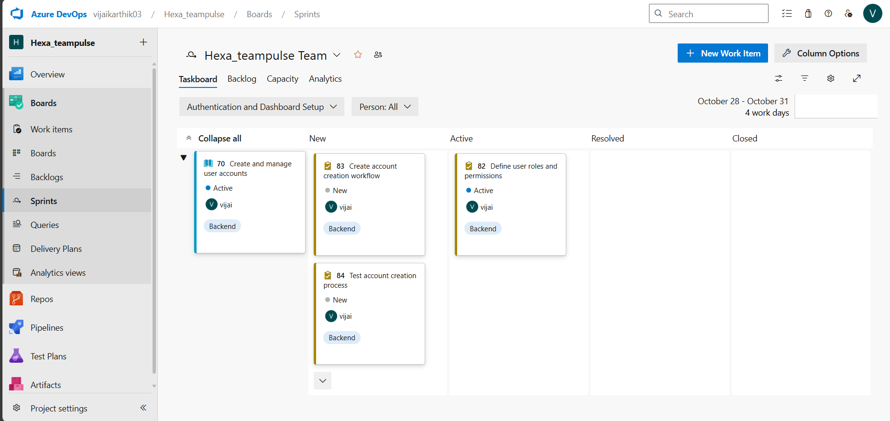

BurnDown Chart

